Chapter 4
SYSTEM DESIGN

4. SYSTEM DESIGN

4.1 Process Model
SDLC is nothing but Software Development Life Cycle. It is a standard which is used by software industry to develop good software.
Stages in SDLC:

- Requirement Gathering
- Analysis
- Designing
- Coding
- Testing
- Maintenance

Requirements Gathering:
The requirements gathering process takes as its input the goals identified in the high-level requirements section of the project plan. Each goal will be refined into a set of one or more requirements. These requirements define the major functions of the intended application, define operational data areas and reference data areas, and define the initial data entities. Major functions include critical processes to be managed, as well as mission critical inputs, outputs and reports. A user class hierarchy is developed and associated with these major functions, data areas, and data entities. Each of these definitions is termed a Requirement. Requirements are identified by unique requirement identifiers and, at minimum, contain a requirement title and textual description.

Analysis Stage:
The planning stage establishes a bird's eye view of the intended software product, and uses this to establish the basic project structure, evaluate feasibility and risks associated with the project, and describe appropriate management and technical approaches. The most critical section of the project plan is a listing of high-level product requirements, also referred to as goals. All of the software product requirements to be developed during the requirements definition stage flow from one or more of these goals. The minimum information for each goal consists of a title and textual description, although additional information and references to external documents may be included. The outputs of the project planning stage are the configuration management plan, the quality assurance plan, and the project plan and schedule, with a detailed listing of scheduled activities for the upcoming Requirements stage, and high level estimates of effort for the out stages.

Designing Stage:
The design stage takes as its initial input the requirements identified in the approved requirements document. For each requirement, a set of one or more design elements will be produced as a result of interviews, workshops, and/or prototype efforts. Design elements describe the desired software features in detail, and generally include functional hierarchy diagrams, screen layout diagrams, tables of business rules, business process diagrams, pseudo code, and a complete entity-relationship diagram with a full data dictionary. These design elements are intended to describe the software in sufficient detail that skilled programmers may develop the software with minimal additional input.

Development (Coding) Stage:
The development stage takes as its primary input the design elements described in the approved design document. For each design element, a set of one or more software artifacts will be produced. Software artifacts include but are not limited to menus, dialogs, data management forms, data reporting formats, and specialized procedures and functions. Appropriate test cases will be developed for each set of functionally related software artifacts, and an online help system will be developed to guide users in their interactions with the software.

Integration & Test Stage:
During the integration and test stage, the software artifacts, online help, and test data are migrated from the development environment to a separate test environment. At this point, all test cases are run to verify the correctness and completeness of the software. Successful execution of the test suite confirms a robust and complete migration capability. During this stage, reference data is finalized for production use and production users are identified and linked to their appropriate roles. The final reference data (or links to reference data source files) and production user list are compiled into the Production Initiation Plan.

Maintenance:
Maintenance team will start with requirement study, understanding of documentation later employees will be assigned work and they will under go training on that particular assigned category.

For this life cycle there is no end, it will be continued so on like an umbrella (no ending point to umbrella sticks).

4.2 System Architecture
A typical architecture of the system is described in Figure 4.2. In the datacollection phase, the data publisher collects data from record owners. In the data publishing phase, the data publisher releases the collected data to a data miner or to the public, called the data recipient, who will then conduct data mining on the published data.

In our system, A corporate company wants to publish its corporate expenses to an external agency.Admin collects the data from all his employees and publish the data to the external research centre by applying anonymization techniques to preserve individual privacy.
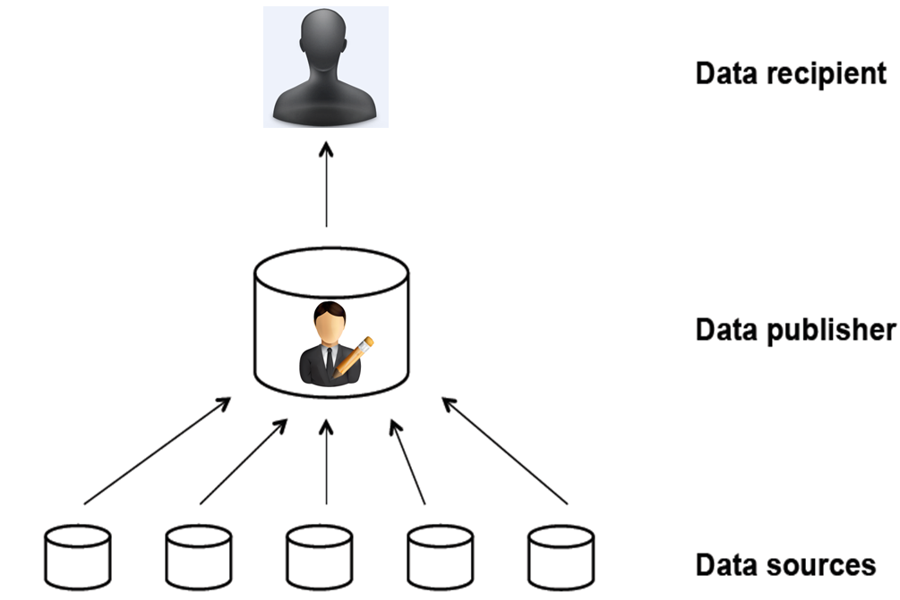
Figure 4.2 Architecture Diagram

4.3 Activity Diagram
Activity Diagrams are graphical representations of workflows of stepwise activities and actions with support for choice, iteration and concurrency. In the Unified Modelling Language, Activity diagrams can be used to describe the business and operational step-by-step workflows of components in a system. An activity diagram shows the overall control.

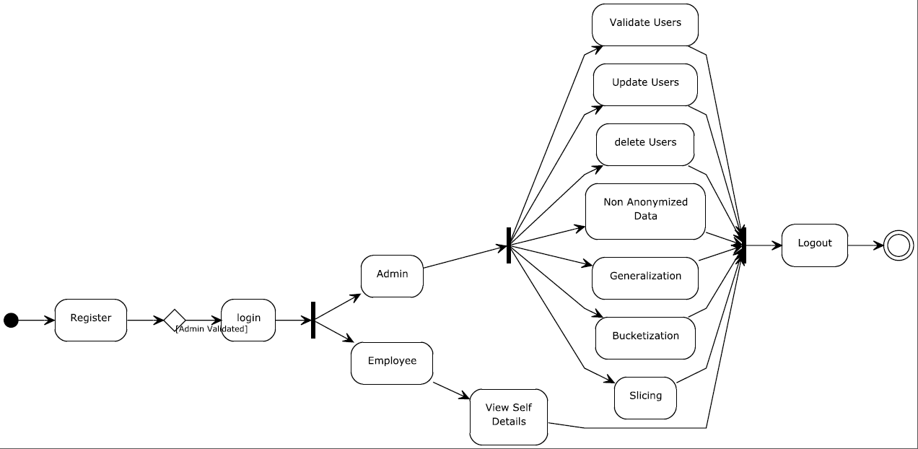
Figure 4.3 Activity Diagram

4.4 Sequence Diagram
A sequence diagram is a kind of interaction diagram that shows how processes operate with one another and in what order. A sequence diagram shows object interactions arranged in time sequence. It depicts the objects and classes involved in the scenario and the sequence of messages exchanged between the objects needed to carry out the functionality of the scenario. A sequence diagram shows, as parallel vertical lines (lifelines), different processes or objects that live simultaneously, and, as horizontal arrows, the messages exchanged between them, in the order in which they occur. This allows the specification of simple runtime scenarios in a graphical manner.
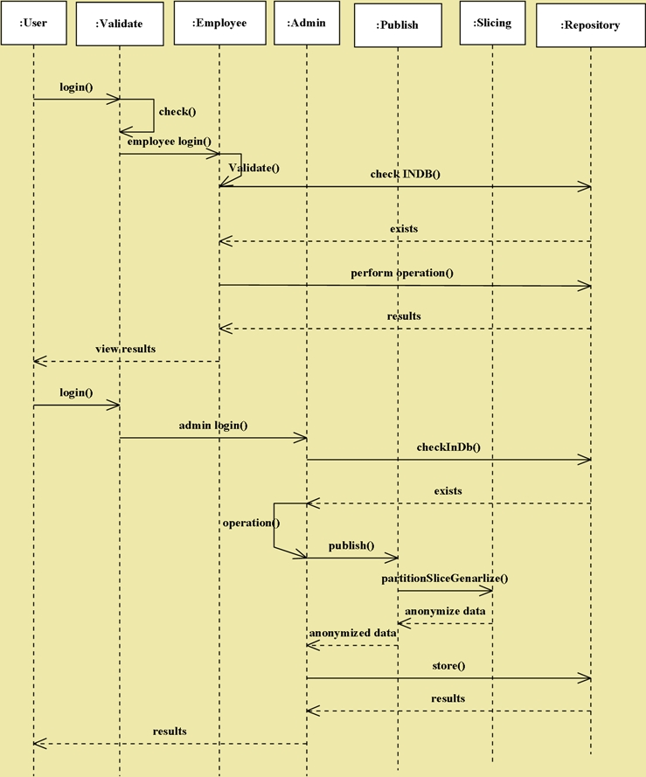
Figure 4.4 Sequence Diagram

4.5 Data Flow Diagram
A data flow diagram (DFD) is a graphical representation of the "flow" of data through an information system, modeling its process aspects. Often they are preliminary step used to create an overview of the system which can later be elaborated. It shows what kinds of information will be input to and output from the system, where the data will come from and go to, and where the data will be stored.
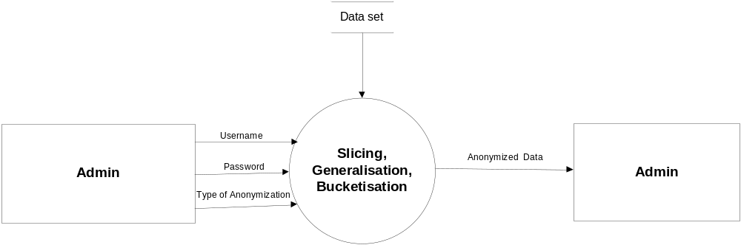
Figure 4.5.1 Level 0 DFD

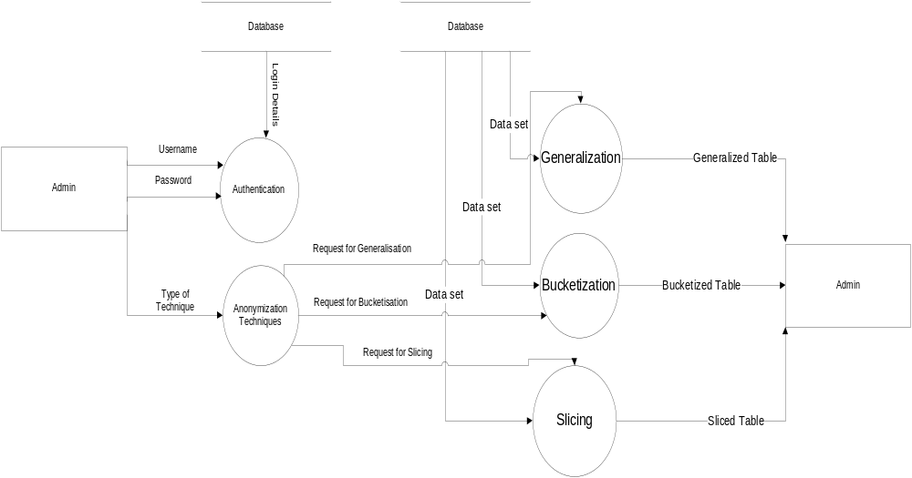
Figure 4.5.2 Level 1 DFD

4.6 Use Case Diagram
A use case diagram is a representation of a user's interaction with the system and depicting the specifications of a use case. A use case diagram can portray the different types of users of a system and the various ways that they interact with the system. This type of diagram is typically used in conjunction with the textual use case and will often be accompanied by other types of diagrams as well.
Use case diagram consistes of
- The actors, usually individuals involved with the system defined according to their roles.
- The use cases, which are the specific roles played by the actors within and around the system.
- The relationships between and among the actors and the use cases.

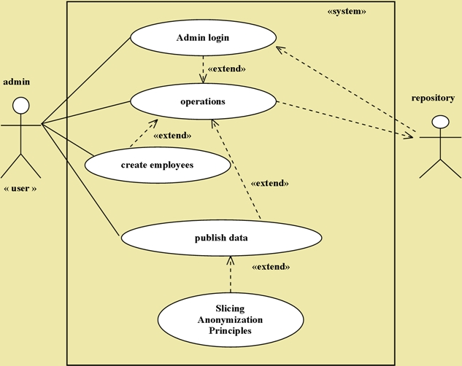
Figure 4.6 Use Case Diagram

4.7 Block Diagram
Block diagram gives the overall structure of the application.

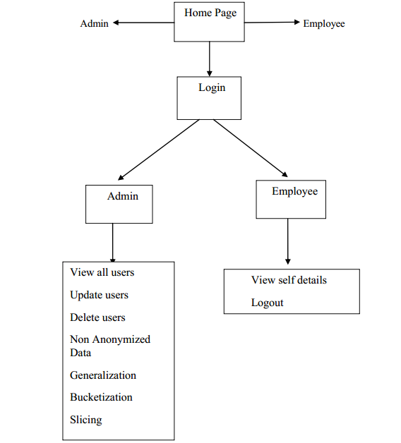
Figure 4.7 Block Diagram

